**ASSIGNMENT 2 FRONT SHEET**

|  |  |  |  |
| --- | --- | --- | --- |
| **Qualification** | **BTEC Level 5 HND Diploma in Computing** | | |
| **Unit number and title** | 13: Website Design & Development | | |
| **Submission date** | 4-5-2022 | **Date Received 1st submission** |  |
| **Re-submission Date** |  | **Date Received 2nd submission** |  |
| **Student Name** | PHAN HONG HANH | **Student ID** | BH00354 |
| **Class** | SE06201 | **Assessor name** | NGUYEN THI HONG HANH |
| **Student declaration**  I certify that the assignment submission is entirely my own work and I fully understand the consequences of plagiarism. I understand that making a false declaration is a form of malpractice. | | | |
|  |  | **Student’s signature** | HANH |

**Grading grid**

|  |  |  |  |  |  |  |
| --- | --- | --- | --- | --- | --- | --- |
| P5 | P6 | P7 | M4 | M5 | D2 | D3 |
|  |  |  |  |  |  |  |

|  |  |  |
| --- | --- | --- |
| **❒ Summative Feedback: ❒ Resubmission Feedback:** | | |
| **Grade:** | **Assessor Signature:** | **Date:** |
| **Signature & Date:** | | |

Table of Contents

I. Introduction 5

B. Content 6

P5. Create a design document for a branded, multipage website supported with medium fidelity wireframes and a full set of client and user requirement 6

1.Use case diagram 6

P6. Use your design document with appropriate principles, standards and guidenes to produce a barnded, multipage wensite supported with realistic content 9

A. Below are some popular technical tools used for website development: 9

B. Landing page(homepage) 11

C. ContactPage: 13

D. Login Page: 17

C. Conclution 49

D. REFERENCE LIST: 49

Figure 1:diagram 7

Figure 2:database design 8

Figure 3:home page 11

Figure 4:Contact us 13

Figure 5:contact us 14

Figure 6:button chat 15

Figure 7:login 17

Figure 8:registration 18

Figure 9:login 19

Figure 10:home page 20

Figure 11: add to cart 23

Figure 12:check out 24

Figure 13:message box 25

Figure 14:our blogs 28

Figure 15:our blogs 29

Figure 16:testimonials 30

Figure 17:login 32

Figure 18: check login 33

Figure 19:check login 34

Figure 20:check login 35

Figure 21: Login 36

Figure 22:Return homepage 37

Figure 23:List product 38

Figure 24:add to cart 39

Figure 25:search product 40

Figure 26:add to cart 41

Figure 27:logout 42

Figure 28:Multi-function device 44

# Introduction

In the dynamic landscape of e-commerce, creating a seamless online shopping experience is paramount for success. As a full-stack web team leader at a prominent creative web solutions and marketing company, our team has been tasked with developing an online shopping mall. This endeavor represents not only a significant opportunity for our company but also a chance to demonstrate our expertise in website designing and development.

To ensure the success of this project, it is imperative to adhere to established principles, standards, and guidelines for website designing and development. This includes a comprehensive review of technical challenges and considerations, culminating in the creation of a detailed design document. This document will serve as the blueprint for our online shopping website, complete with wireframes, functional illustrations, and a thorough set of client and user requirements.

As the team leader, my role extends beyond mere supervision; I must guide and empower my team to leverage cutting-edge web design and development technologies, tools, and techniques. Collaboration and adherence to the design document are essential for achieving our objectives. Regular comparison between the developed multipage website and the design document allows for continuous evaluation and refinement, ensuring alignment with client expectations.

However, creating a high-quality online shopping website goes beyond design and development. It requires a robust quality assurance process to identify and rectify any issues that may compromise the user experience. As such, I advocate for the implementation of a comprehensive test plan throughout the design and development stages. By meticulously reviewing and analyzing test results, we can evaluate the efficacy of our quality assurance process and identify areas for improvement.

In this report, we will delve into the methodologies, strategies, and best practices employed by our team in the creation of the online shopping website. From the initial design phase to the rigorous testing phase, each step reflects our commitment to delivering a superior product that meets and exceeds client expectations. Through our collective efforts and dedication to excellence, we aim to set a new standard for online shopping experiencesuction

# B. Content

# P5. Create a design document for a branded, multipage website supported with medium fidelity wireframes and a full set of client and user requirement

## 1.Use case diagram

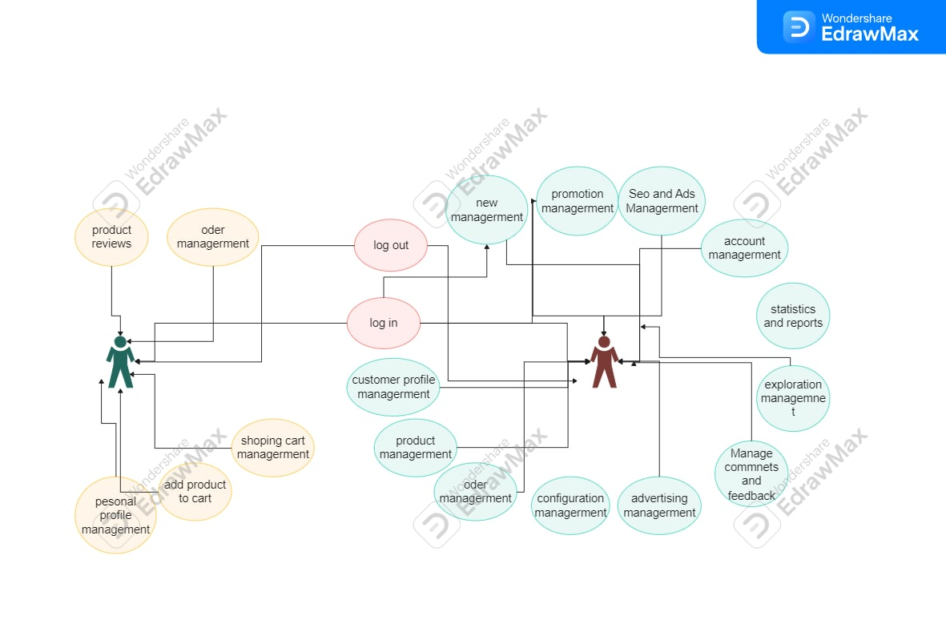

Figure 1:diagram

Database design:

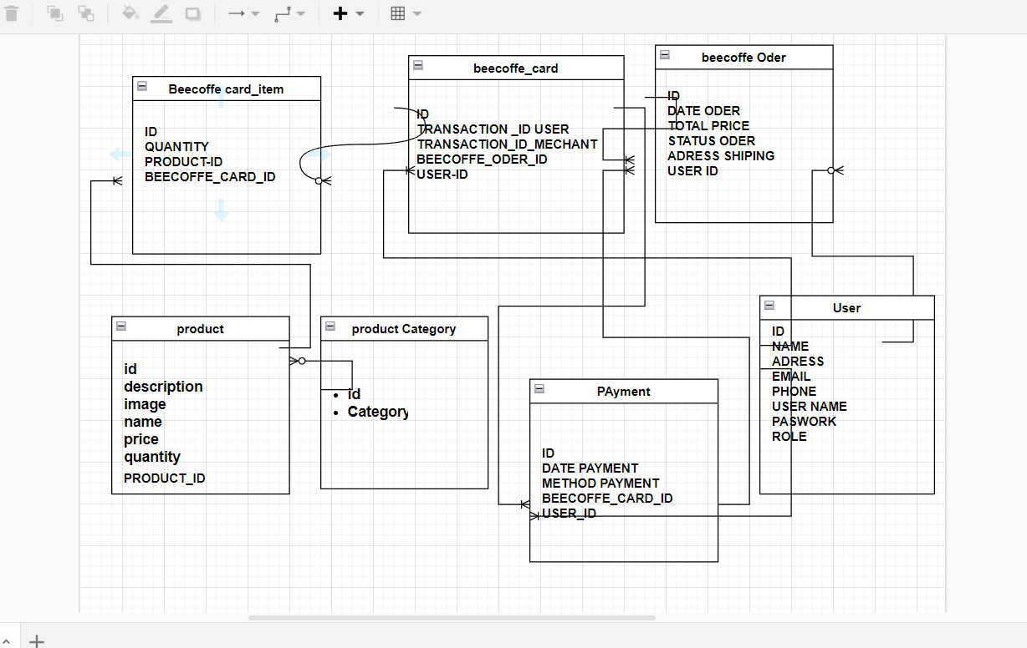

Figure 2:diagram

**Design document**

HOME PAGE: 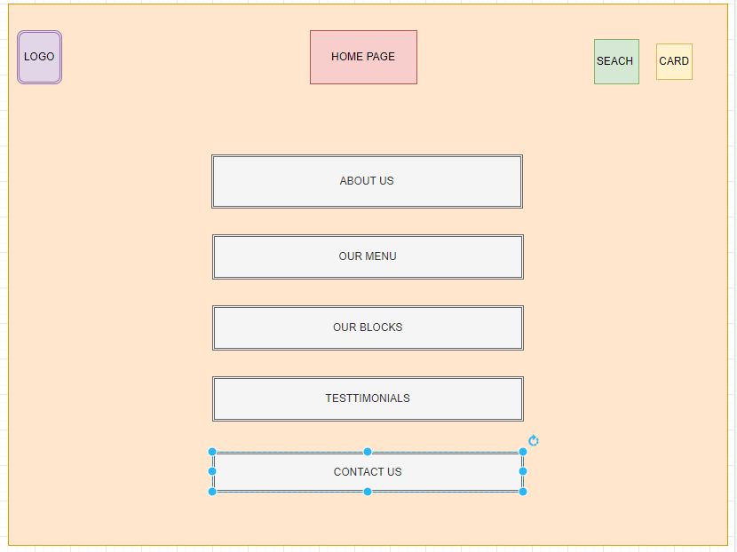

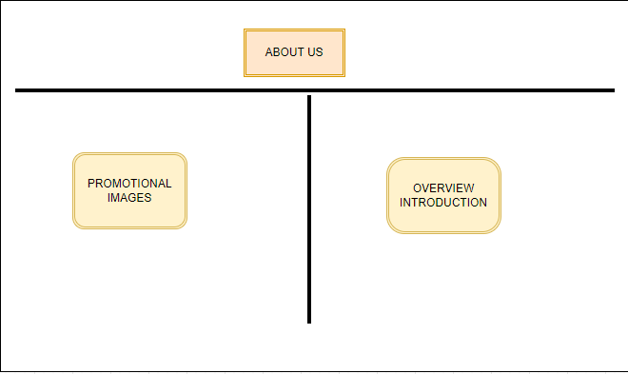ABOUT US:

OUR BLOCK:

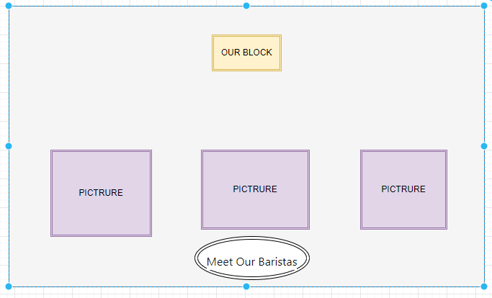

TESTIMONIAL :

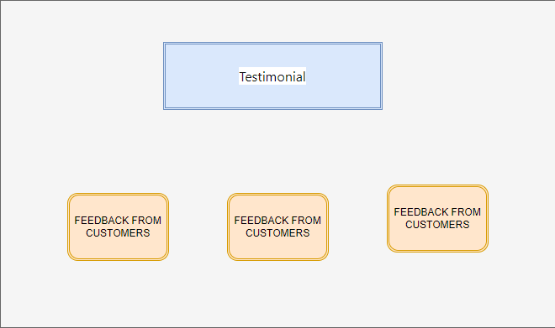

CONTACT US :

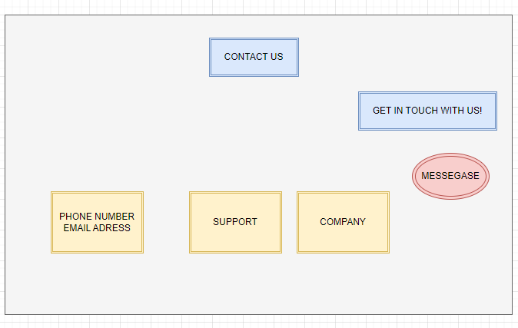

# P6. Use your design document with appropriate principles, standards and guidenes to produce a barnded, multipage wensite supported with realistic content

## Below are some popular technical tools used for website development:

1. **Programming Languages**:
   * **HTML/CSS**: Used for creating the structure and styling of web pages.
   * **JavaScript**: Used for creating interactive and dynamic functionalities on web pages.
2. **JavaScript Frameworks and Libraries**:
   * **React.js**: A popular JavaScript library for building user interfaces.
   * **AngularJS or Angular**: Popular JavaScript frameworks for developing Single Page Applications (SPAs).
   * **Vue.js**: A lightweight and easy-to-use JavaScript framework.
3. **Backend Development**:
   * **Node.js**: A JavaScript runtime environment commonly used for building the backend of web applications.
   * **PHP**: A popular Node.js framework for building web applications and APIs more easily.
4. **Database**:

**MySQL or PostgreSQL**: Common relational database management systems for web applications.

1. **Version Control Tools**:
   * **Git**: A popular distributed version control system, often used to track and manage project source code.
2. **Testing and Debugging Tools**:
   * **Chrome DevTools**: Integrated tool in the Chrome browser for inspecting, debugging, and optimizing web pages.
   * **Postman**: An application for testing APIs, making it easier to develop and test API-based web applications.
3. **Optimization and Project Management Tools**:
   * **Webpack or Parcel**: Tools for automating the process of bundling and optimizing JavaScript code and other resources for web applications.
   * **npm or Yarn**: Popular package management tools for JavaScript, helping manage dependencies and download necessary libraries for the project.
4. **Design and User Interface Tools**:
   * **Adobe XD or Sketch**: User interface design tools for creating wireframes and designs for web pages.
   * **Figma**: An online user interface design tool with collaboration features.

Next I will introduce the functions of the website in many different languages that I have learned

## B. Landing page(homepage)

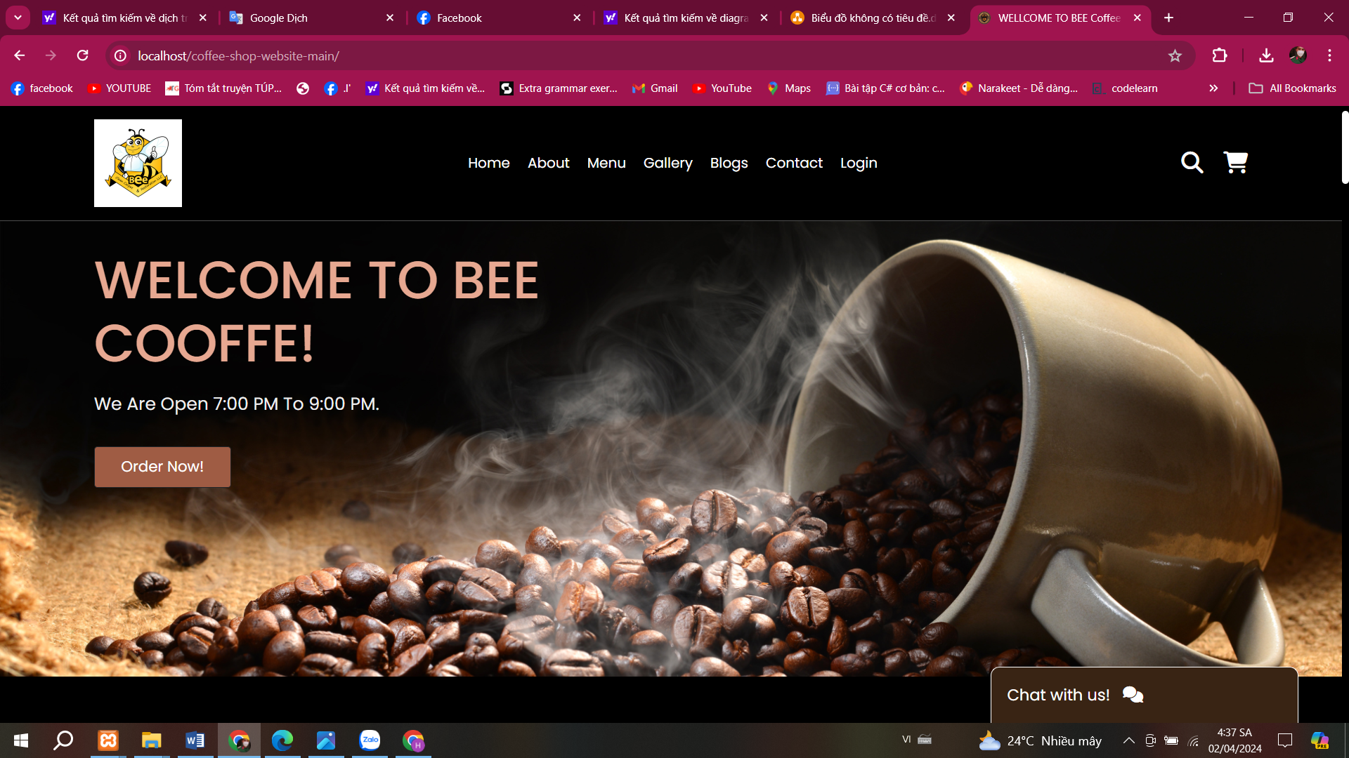

Figure 3:home page

The homepage of an e-commerce website serves several important functions, aimed at attracting and retaining customers. Here are some key functions of the homepage in an e-commerce website:

1. *Displaying Featured Products and Services:* The homepage often showcases the most prominent products and services of the store, making it easy for users to access and browse.
2. *Creating First Impressions:* The homepage must reflect the brand identity and capture the attention of customers at first glance.
3. *Menu and Navigation:* Providing a clear menu or navigation bar helps users easily navigate to product pages, categories, or other functions on the website.
4. *Search Bar*: Offering a search bar allows users to quickly search for specific products they are interested in.
5. *Updating News and Promotions*: The homepage often updates the latest news about products, services, and promotional programs to encourage customers to make purchases.
6. *Customer Feedback*: Displaying reviews and feedback from previous customers helps build trust and credibility for the products and services.
7. *Links to Important Pages*: Including links to pages such as About Us, Contact Us, Shipping and Returns information helps users access necessary information easily.
8. *Mobile-Friendly Interface*: The homepage needs to be designed to be responsive on mobile devices, as many users access the internet through mobile phones nowadays.

## C. ContactPage:

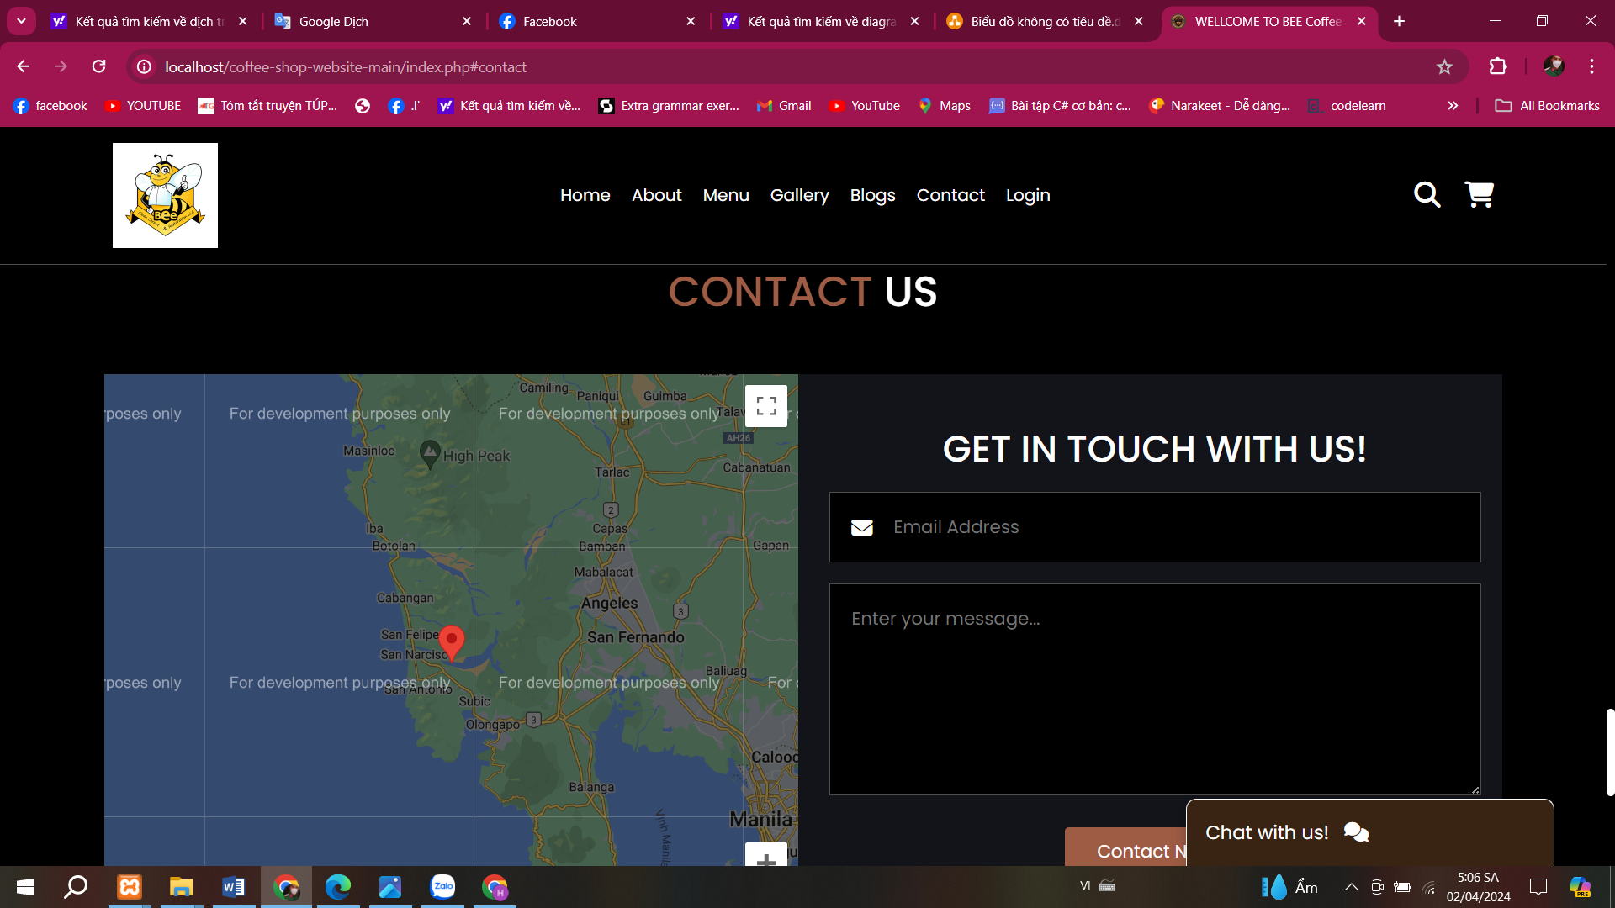

Figure 4:Contact us

In the contact section, I will put it below the homepage because it needs to contain customer feedback and contact so I can manage product review information. Usually it will be the address of my coffee shop so customers can have it. You can contact or visit the shop. I used js and css to design it and a function to display the google map address on the website.

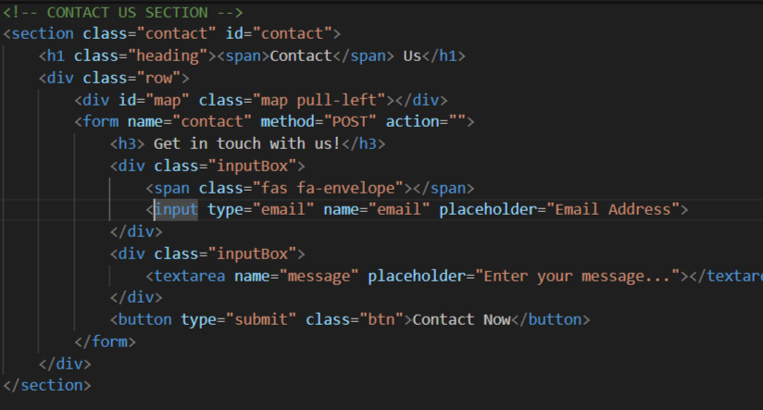

Figure 5:contact us

Chat wish us (source code)

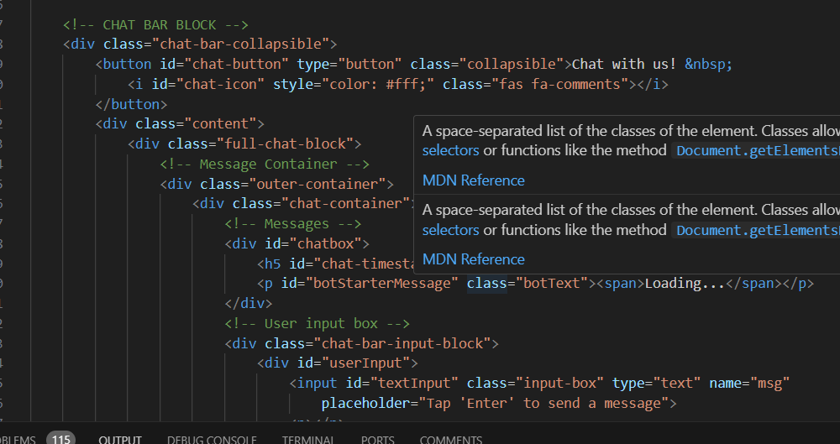

Figure 6:button chat

The "Contact" section on a café website serves as a vital point of interaction between the café and its customers. Here are the key functions of the "Contact" section:

1.**Location and Hours**: Providing the physical address of the café along with its operating hours allows customers to easily find and visit the café.

2. **Contact Information**: Offering contact details such as phone number and email address enables customers to get in touch with the café for inquiries, reservations, or other purposes.

3. **Map Integration**: Integrating a map or providing directions helps customers navigate to the café's location seamlessly, especially if they are unfamiliar with the area.

4.**Online Reservation or Booking**: If applicable, allowing customers to make reservations or book tables online simplifies the process and enhances customer convenience.

5. **Feedback and Inquiries**: Offering a form or contact option for customers to leave feedback, ask questions, or provide suggestions fosters engagement and helps improve customer satisfaction.

6. **Social Media Links**: Providing links to the café's social media profiles allows customers to stay updated on the latest news, events, and promotions.

7. **Accessibility Information**: Including information about the café's accessibility features for individuals with disabilities demonstrates inclusivity and helps customers plan their visit accordingly.

8. **Privacy Policy:** Informing customers about the café's privacy policy regarding the handling of their contact information and personal data promotes transparency and trust.

In essence, the "Contact" section plays a crucial role in facilitating communication between the café and its customers, enhancing the overall customer experience, and fostering a sense of community and connection.

## D. Login Page:

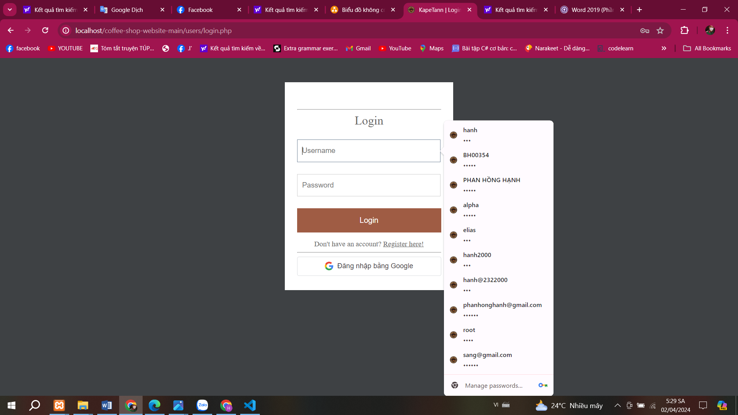

Figure 7:login

This is my login interface designed to allow customers to log in to their accounts to interact with the website. If they do not have an account, allow them to register for a BeeCoffe account**.**

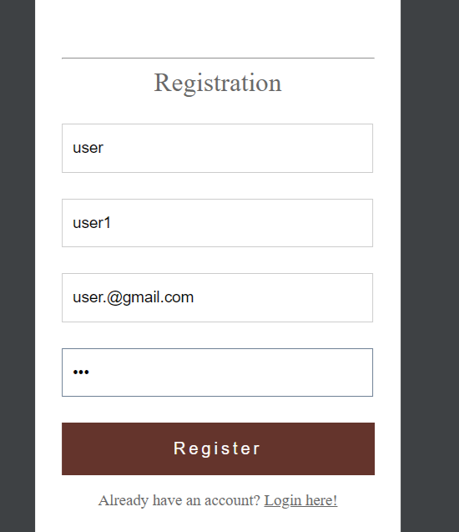Js allows you to conveniently and quickly suggest accounts and passwords from previous logins. If you do not have an account, you can log in with your Google account to log in directly or you can register for an account. BeeCoffee

Figure 8:registration

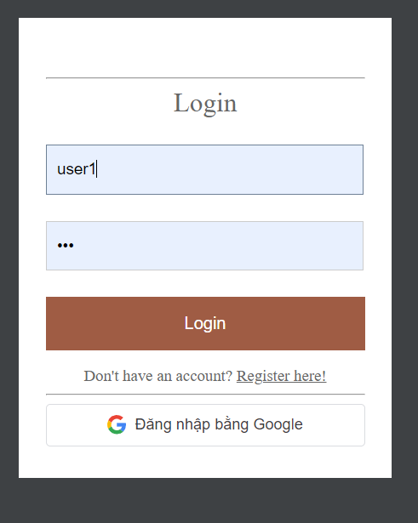

Figure 9:login

And when the registration information is valid, it will be transferred to the login interface

At this point, the system will notify you of successful login and automatically redirect you to the home page with a greeting

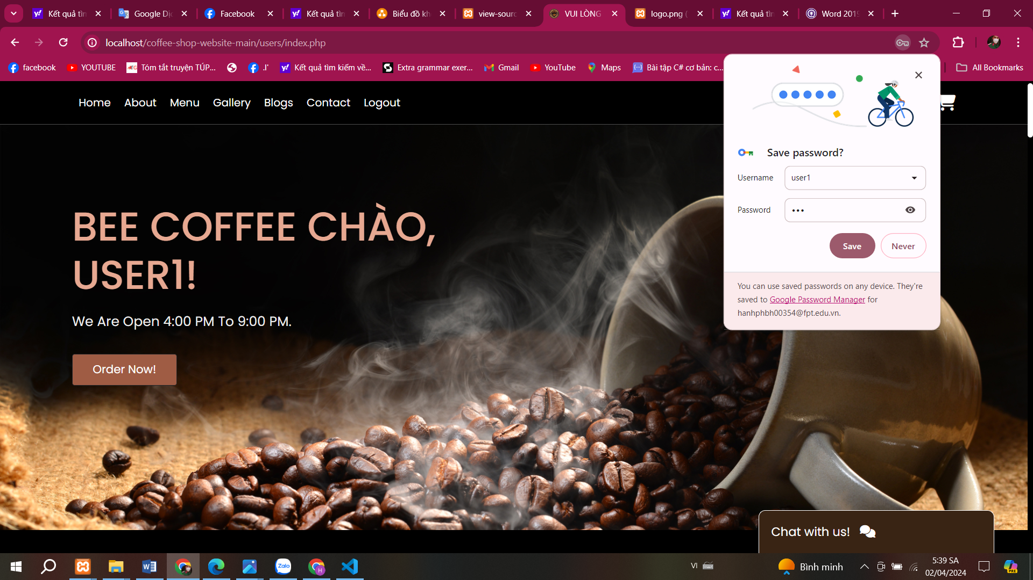

Figure 10:home page

Customers can now discover everything they want to buy and allow interactive ordering and evaluation of BeeCoffe.

The "Login" feature on a coffee-selling website serves several important functions related to user authentication and access control. Here are the key functions:

1.User Authentication: The primary function of the "Login" page is to authenticate users by verifying their credentials, typically a username/email and password. This ensures that only registered users with valid credentials can access restricted areas of the website.

2. Access to Account Information: Once logged in, users can access their account information, such as personal details, order history, payment methods, and shipping addresses. This allows users to manage their accounts and track their past orders easily.

3. Customized Experience: Logged-in users may receive a more personalized experience, such as recommended coffee products based on their past purchases or preferences. The website can tailor content and promotions to match users' interests, enhancing the overall user experience.

4. Secure Transactions: Authentication ensures that users can securely complete transactions, such as purchasing coffee products online. By logging in, users can access secure payment gateways and encrypted communication channels to protect their sensitive information during transactions.

5. Wishlist and Favorites: Logged-in users may have the option to create wishlists or mark favorite coffee products for future reference. This feature allows users to save items they are interested in and easily access them during subsequent visits to the website.

6. Communication and Support: The "Login" page may provide links to customer support resources, such as FAQs, contact forms, or live chat services. This allows users to seek assistance or resolve issues related to their accounts, orders, or coffee products.

7. Subscription Management: If the website offers subscription services for coffee delivery or special offers, logged-in users can manage their subscription preferences, including frequency, coffee varieties, and delivery addresses.

8. Data Security and Privacy: The "Login" feature ensures that users' personal information and transactional data are protected. The website should adhere to relevant privacy regulations and implement security measures, such as encryption and secure authentication protocols, to safeguard user data.

d. A My Card Page:

*I don't do the functions on different pages. I let it all be done on the home page because I want minimalism and cooffe style. Customers can order and interact on the interface and Cart function. Execute directly on Home Page*

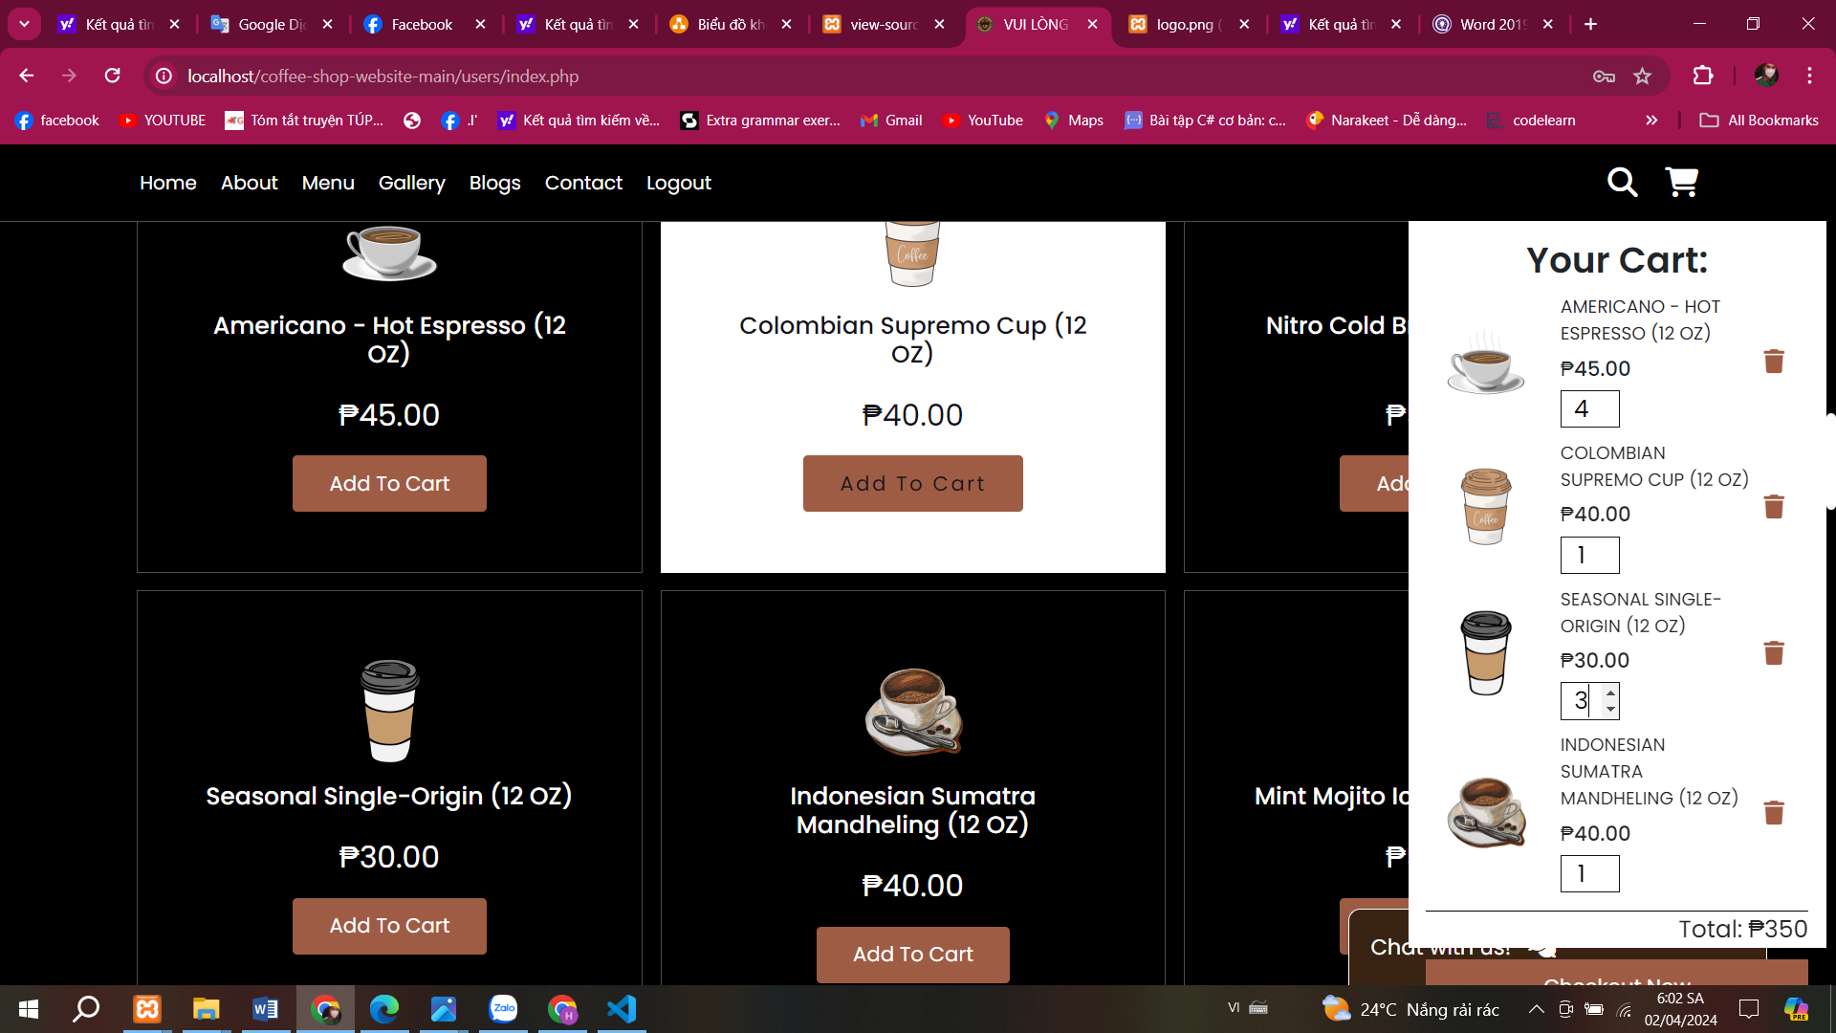

Figure 11: add to cart

In this interface, customers can search for the desired product and add it to the cart. They can choose the quantity of the type of coffee they want to order. And the products will be displayed on the add to card interface. Allows you to charge for the product according to product type and quantity

Source code :

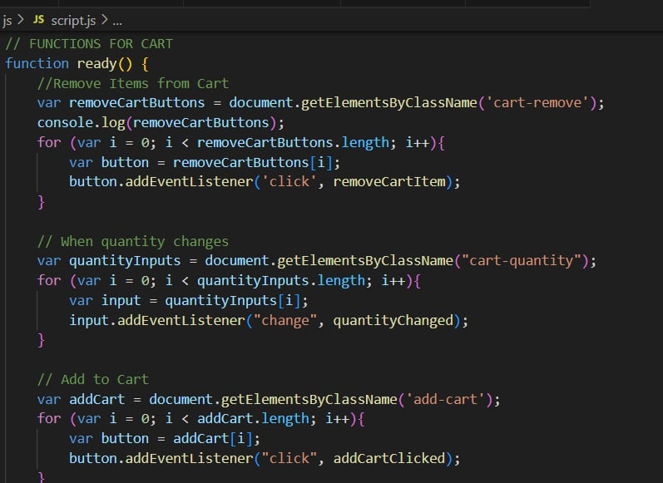

This code appears to be part of a JavaScript script that is designed to enhance the functionality of an e-commerce website's shopping cart. Let's break it down:

1. **Remove Items from Cart**: The script first selects all elements in the document with the class cart-remove (presumably these are buttons used to remove items from the cart). It then iterates through each of these elements and adds an event listener that listens for a click event. When clicked, it calls the function removeCartItem.

**When Quantity Changes**: Next, the script selects all elements in the document with the class cart-quantity. These elements are likely input fields where users can specify the quantity of items they want to purchase. Similar to the previous step, the script adds an event listener to each of these input fields, listening for a change event. When the quantity changes, it calls the function quantityChanged. 3.

**Add to Cart**: Finally, the script selects all elements in the document with the class add-cart. These are likely buttons that users can click to add items to their cart. Like the previous steps, it adds an event listener to each of these buttons, listening for a click event. When clicked, it calls the function addCartClicked. In summary, this code sets up event listeners for three different actions related to the shopping cart functionality: removing items from the cart, changing the quantity of items in the cart, and adding items to the cart. Each action triggers a specific function to handle the corresponding functionality.



Customers can change the type of cooffe quantity they need to order before making a purchase

This function addProductToCart(title, price, productImg) is designed to add a product to the shopping cart in an e-commerce website. Let's break it down:

**Creating Cart Bo**: It starts by creating a div element with the class cart-box using document.createElement(). Then it adds the class cart-box to this newly created div using classList.add() method.

2. **\*Finding Cart Content**: It selects the element with the class cart-content, presumably the container where all the items in the cart are displayed.

**Checking for Duplicate Item**: It loops through all the elements with the class cart-product-title within the cart content. This loop is to check if the product with the same title is already in the cart. If it finds a match, it displays an alert message saying "You have already added this item to cart!" and exits the function using return.

**Constructing Cart Box Content\***: If the item is not already in the cart, it constructs the content of the cart box using a template literal (cartBoxContent). This content includes an image of the product, the product title, price, and an input field for the quantity. Additionally, it includes a trash icon for removing the item. **Appending to Cart**: The content constructed is set as the HTML content of the cartShopBox using innerHTML. Then this box is appended to the cartItems container using append() method. 6. **\*Returning the Cart Box\***: Finally, the function returns the cartShopBox.

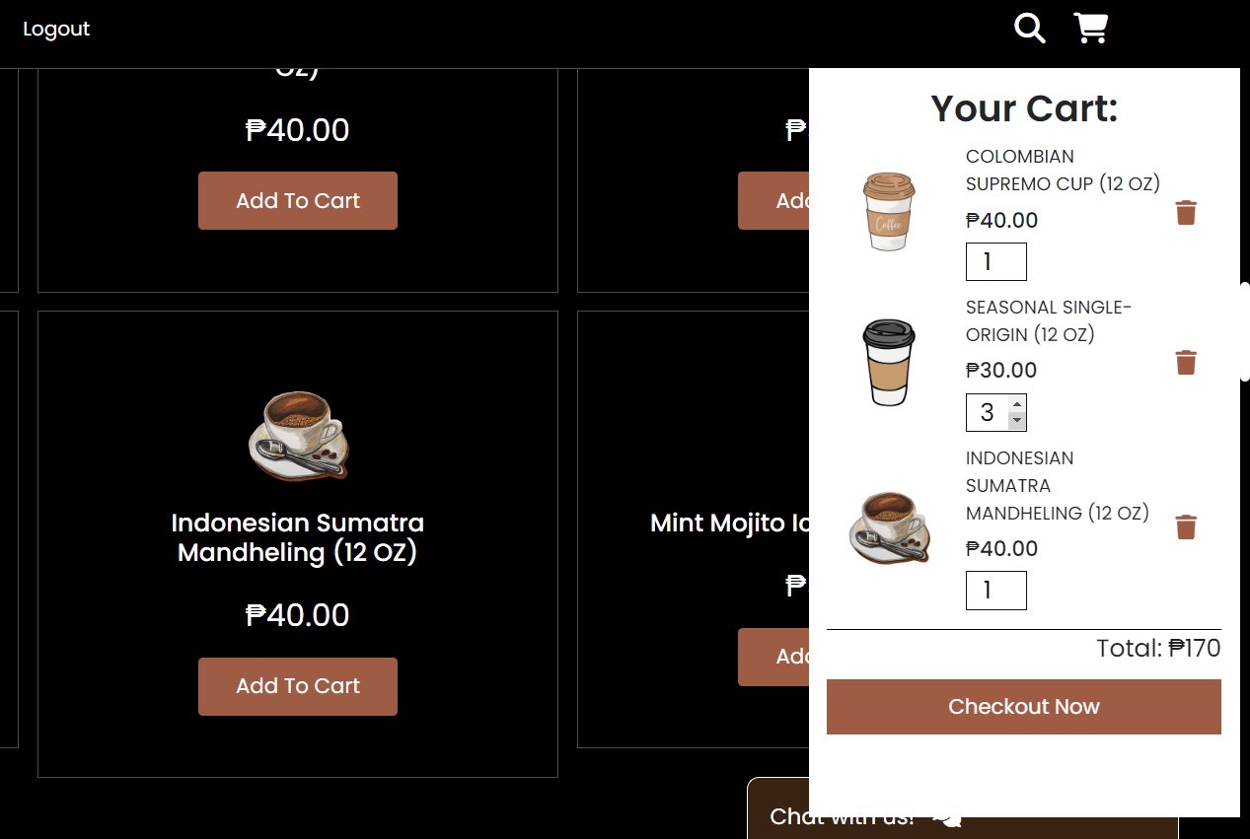

Figure 12:check out

After clicking checkout, the system will send a thank you note

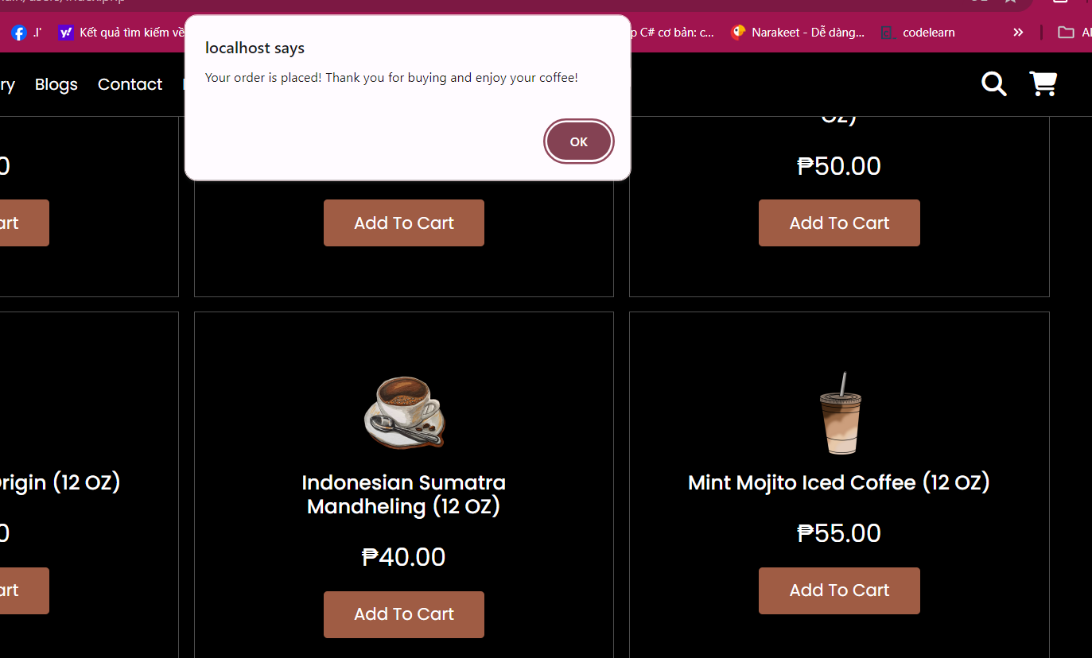

Figure 13:message box

The "Add to Cart" function on a coffee-selling website has the following main functions:

1. **Add products to the cart**: The basic function of "Add to Cart" is to allow users to add products to their online shopping cart when they are interested in a specific product.
2. **Temporary product storage**: Products added to the cart are temporarily stored during the user's session. This allows them to continue browsing the website and add other products to the cart before deciding to check out.
3. **Manage quantity and product variants**: "Add to Cart" provides options for users to specify the quantity of a specific product they want to purchase and select product variants (such as size, color, etc.) if available.
4. **Display total quantity and value**: When products are added to the cart, the website typically displays the total quantity of products and the total value of the cart. This helps users easily track and manage their orders before checkout.
5. **Convenient for adjusting orders**: Users can easily edit or remove products from the cart before completing the checkout process.
6. **Calculate total cost and shipping fees**: "Add to Cart" provides detailed information on the total cost of the order, including product prices and shipping fees (if applicable). This helps users get an overview of the total amount they will need to pay.
7. **Redirect to the checkout page**: When users have added enough products to the cart and are ready to check out, the "Add to Cart" function typically redirects them to the checkout page to complete the purchase process.

**e.OUR BLOCK**

"OurBlock" could be a part or feature on a coffee-selling website, but no specific information is provided about its function. Here are some ideas about the functions that "OurBlock" could have on a coffee-selling website:

Community Information Block: "OurBlock" could be a section of the website dedicated to sharing community information related to coffee, including news, local events, stories about coffee origins, and other relevant information.

Online Forum or Community: If the website features a forum or online community, "OurBlock" could be a part of the forum specifically for coffee enthusiasts. Users could exchange opinions, suggest brewing methods, share experiences, and meet others with similar interests.

Local Community Introduction Section: "OurBlock" could be a section on the website's homepage providing information about local communities that the coffee shop supports or interacts with. This could include events and social activities that the shop participates in.

Sharing Stories and Experiences: "OurBlock" could be a place where customers can share their stories or experiences with coffee from the shop. This could be a part of the website or a separate feature to create a community space for coffee lovers.

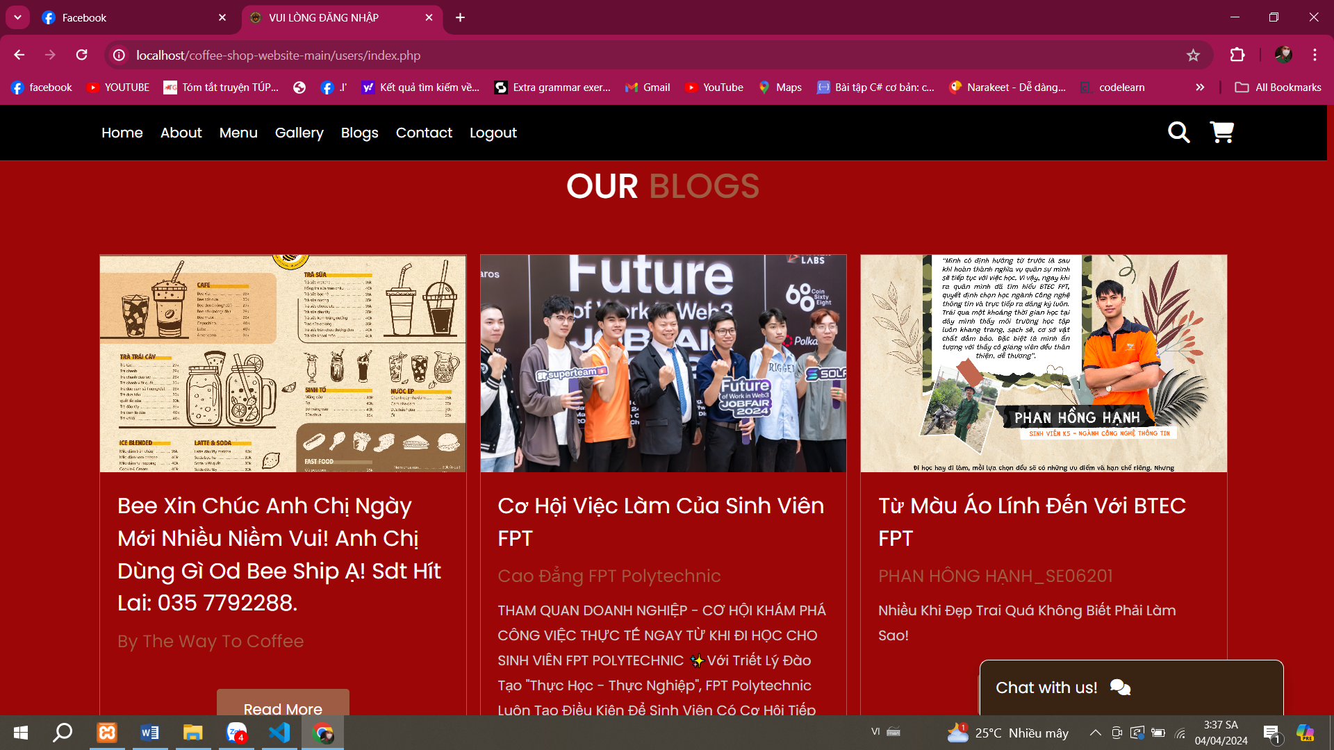

Figure 14:our blogs

In the out block section, I can add information such as promotions and information related to services and nearby information. Because Bee Coffee is a regular store, there may be school content. Clicking on the READMORE line can lead to a page full of that information. For example: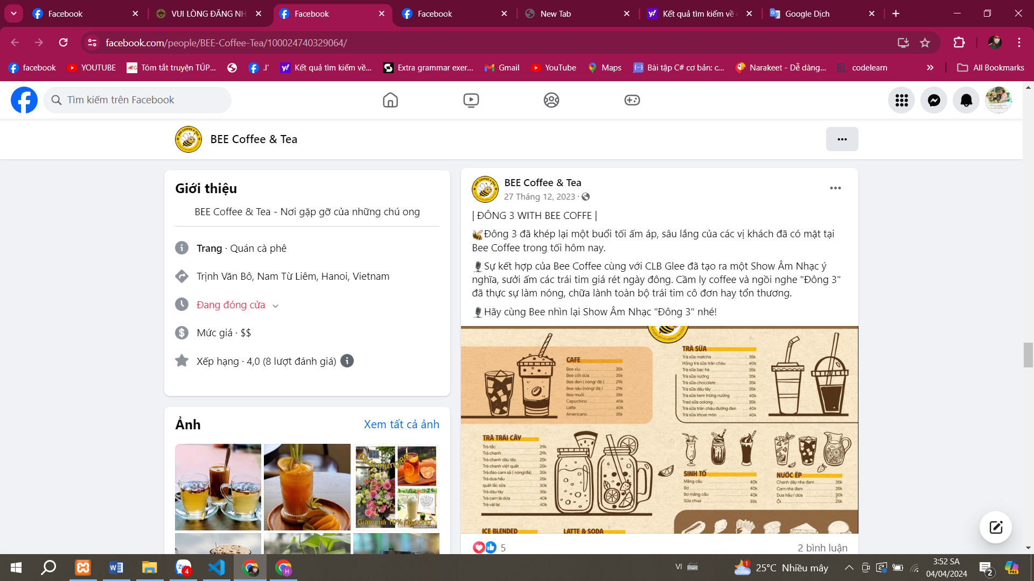

Figure 15:our blogs

f.Testimonial

Applying the "testimonials" function to a cup-selling website can increase persuasion and trust from customers. Here's how to implement it:

1. **Customer Review Section:** Create a dedicated section on the website for reviews and testimonials from previous customers. Allow customers to submit their experiences with using the cups, including images if possible.

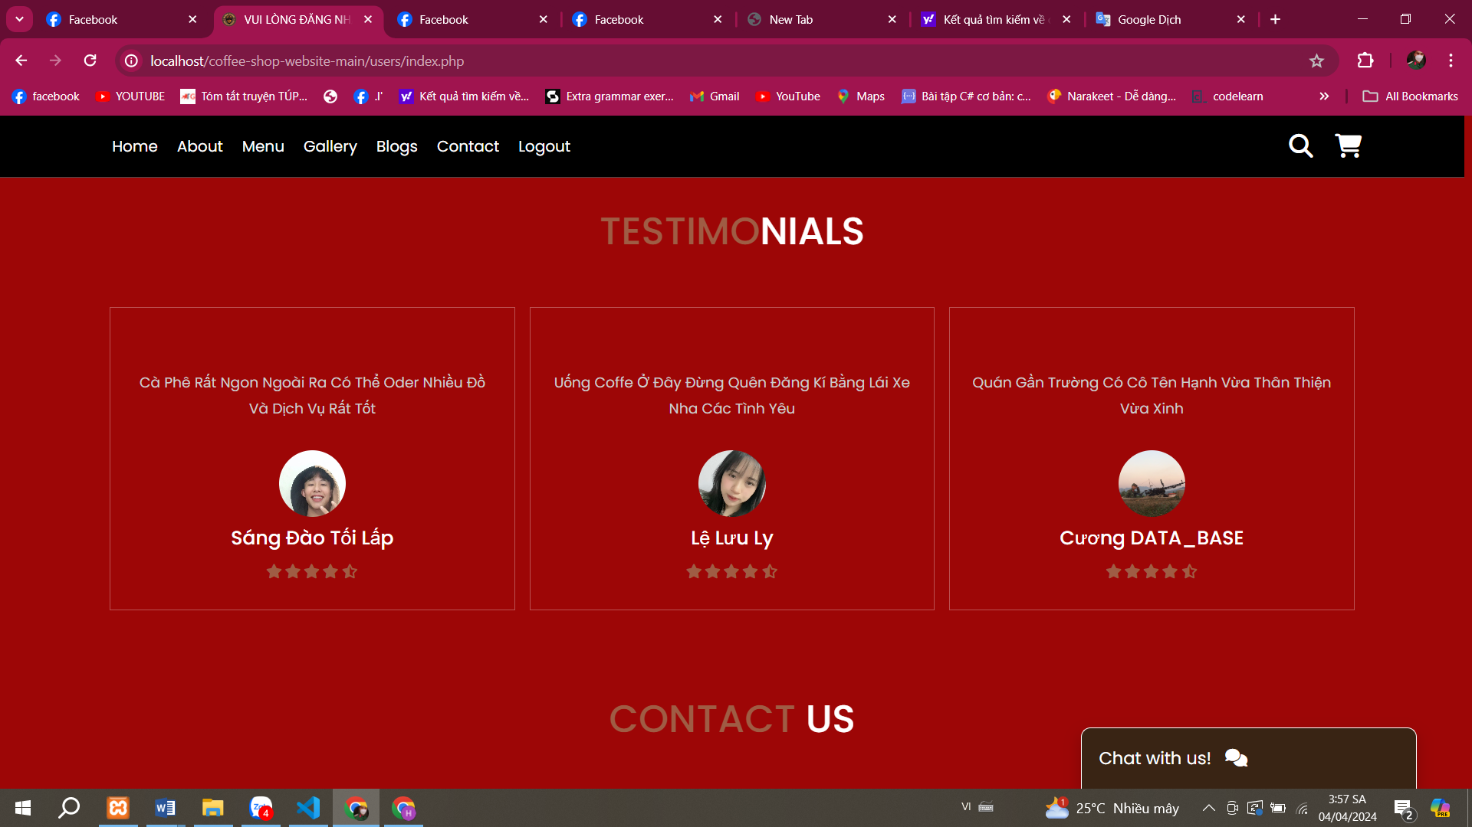

Figure 16:testimonials

1. **Display Customer Photos and Names:** To enhance persuasion, display customer photos and names alongside their testimonials. This makes the testimonials more specific and shows sincerity and credibility.
2. **Rating Classification:** Establish a rating system for reviews, such as "Positive," "Average," and "Negative." This helps customers easily search and analyze information.
3. **Diverse Display Methods:** To make the website more dynamic, use a variety of methods to display reviews, such as slideshows, carousels, or scrolling on the homepage or specific product pages.
4. **Enhance Interaction:** In addition to reading reviews, customers may also want to interact with them. Allow them to comment or inquire about specific reviews, creating a discussion community on your website.
5. **Regular Updates:** Ensure that reviews are regularly updated, especially when there are new feedback from customers. This helps maintain the freshness and relevance of the website.

Organizing creative and engaging customer testimonials will help increase trust and sales performance on your website.

# P7. Create a suitable Test Plan identifying key performance areas and use it to review the functionality and performance of your website. User Experience (UX) and User Interface (UI)

**Functional Requirements:**

1. **Login and Registration:**
   * Test the login functionality using username and password.

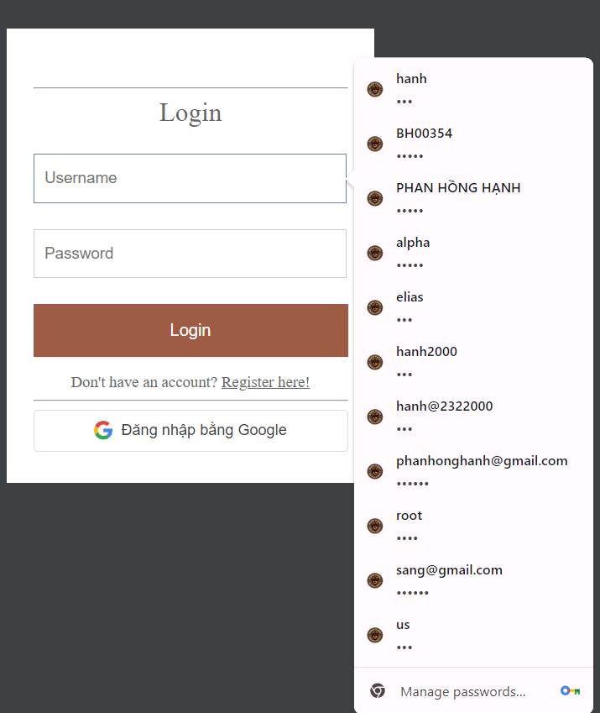

Figure 17:login

Source code :

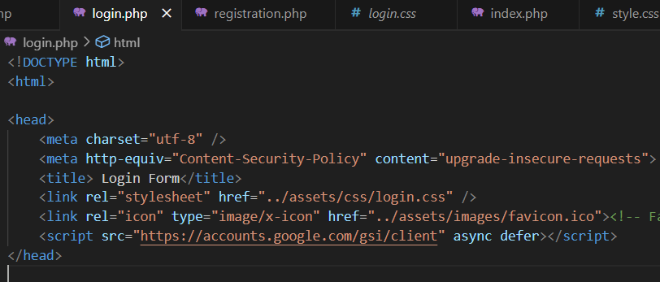

Figure 18: check login

*When clicking on the login button on the homepage, it will lead to a login form allowing users to log in. In case there is no account that allows users to register in register here!*

* + Verify the registration feature by entering required information.

*During the registration process, all information fields must be filled in. If missing, a notification will be issued. Please fill in all information.*

*Sign in completely and in the correct format. Registration will be allowed and a message will appear "Do you want to save your login information?"*

*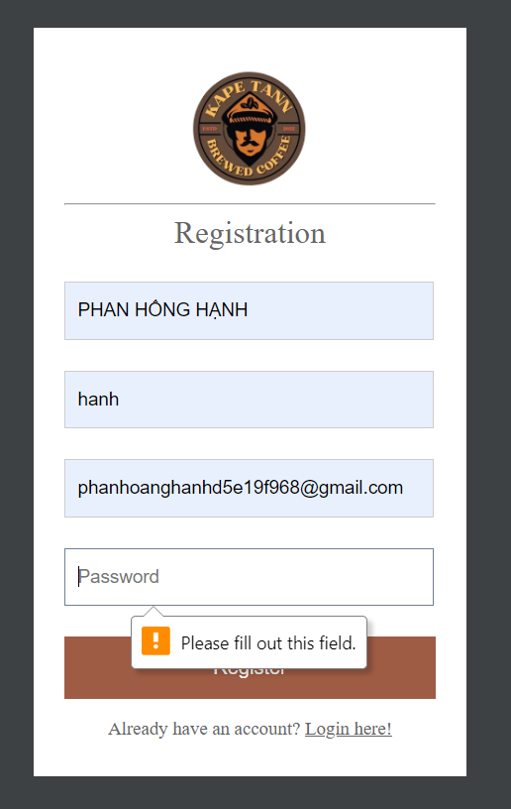After successful registration, you will automatically switch to the login form. Enter the account you just registered*

Figure 19:check login

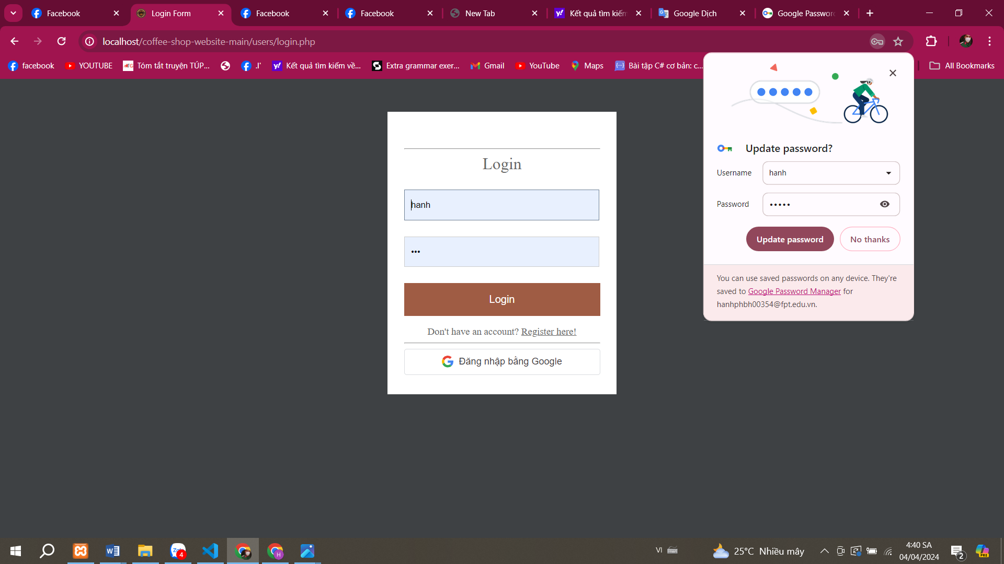

Figure 20:check login

*In case I enter incorrectly, it will notify me that I lack login information similar to when registering*

* + Ensure correct error messages are displayed when entering incorrect login or registration information.

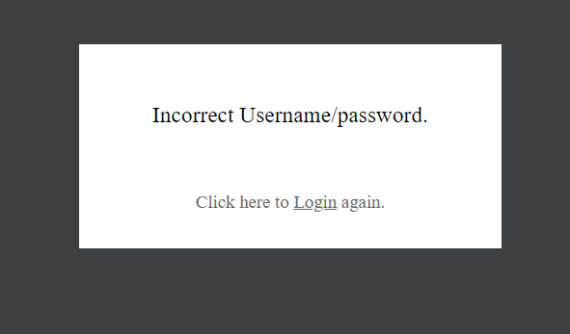

Figure 21: Login

*If the registered information is correct, allow successful login and go to the home page*

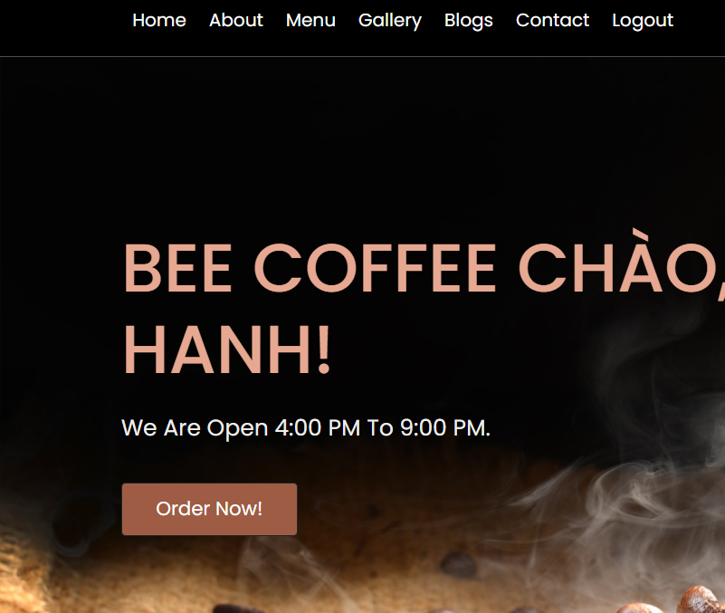

Figure 22:Return homepage

1. **View Products:**
   * Test the functionality to display a list of available coffee products on the website.

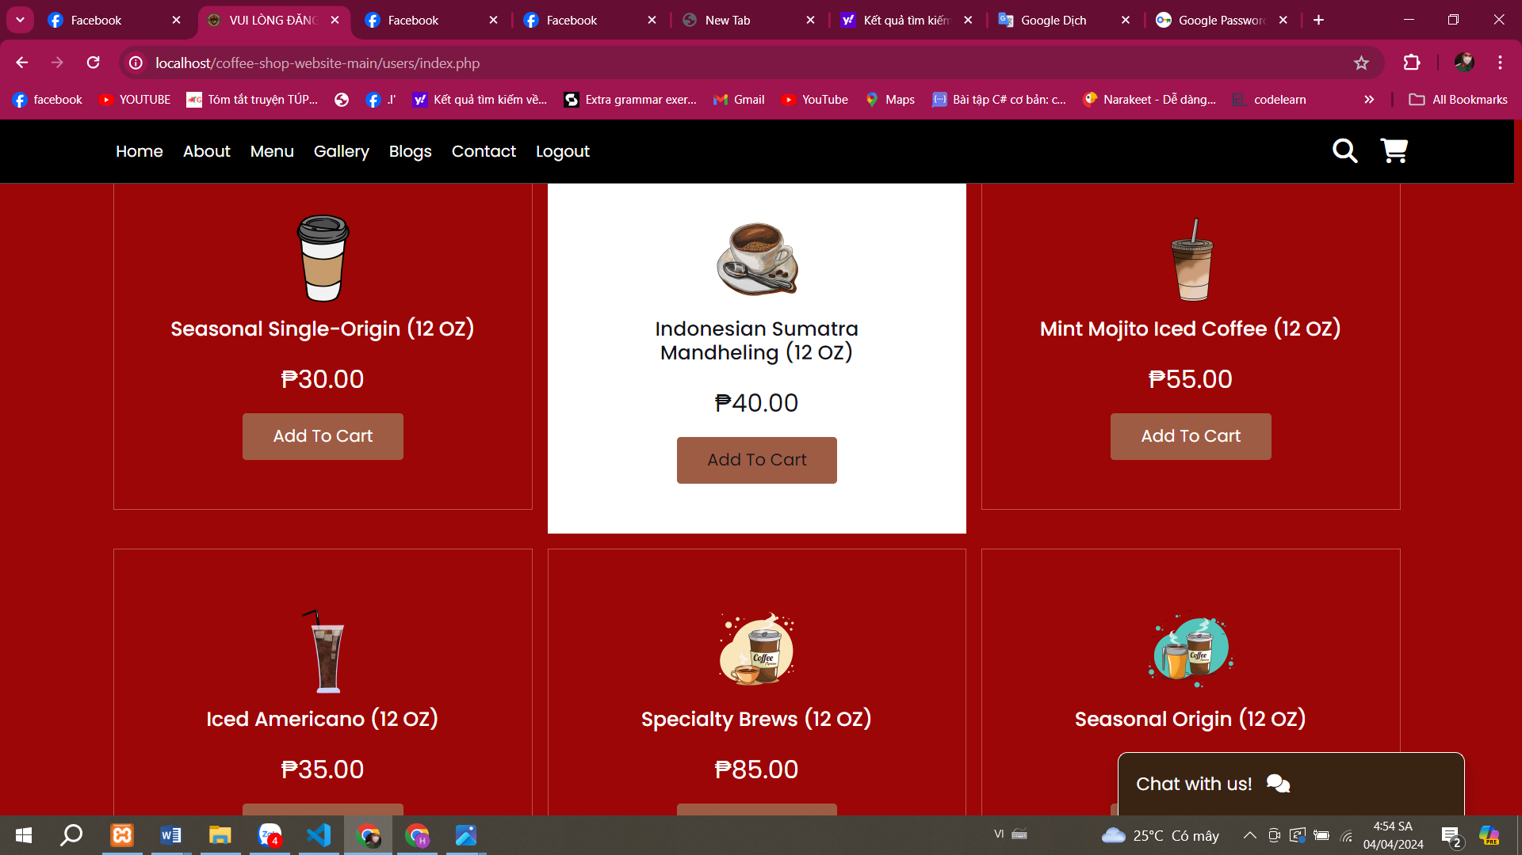

Figure 23:List product

*SOURCECODE:*

* + Ensure that descriptions, prices, and images of products are displayed accurately.

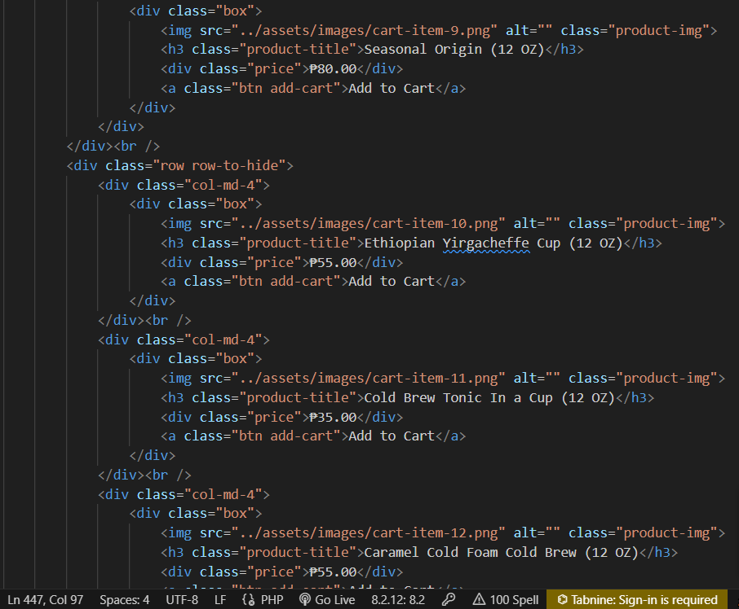

Figure 24:add to cart

* + Test the search functionality to ensure accurate results.

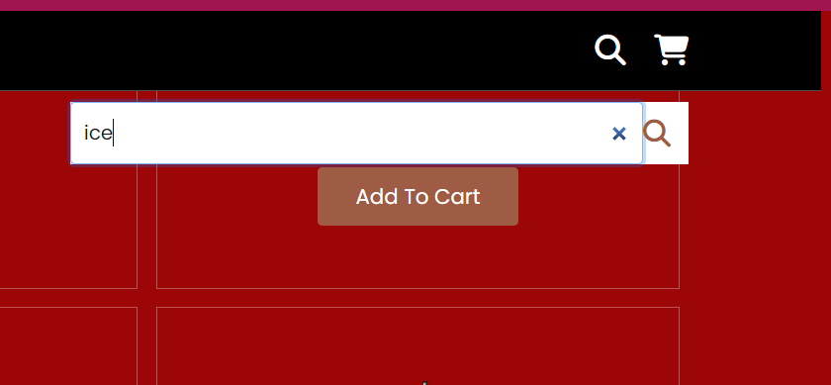

Figure 25:search product

1. **Add to Cart and Checkout:**
   * Test the functionality to add products to the cart and update quantities.

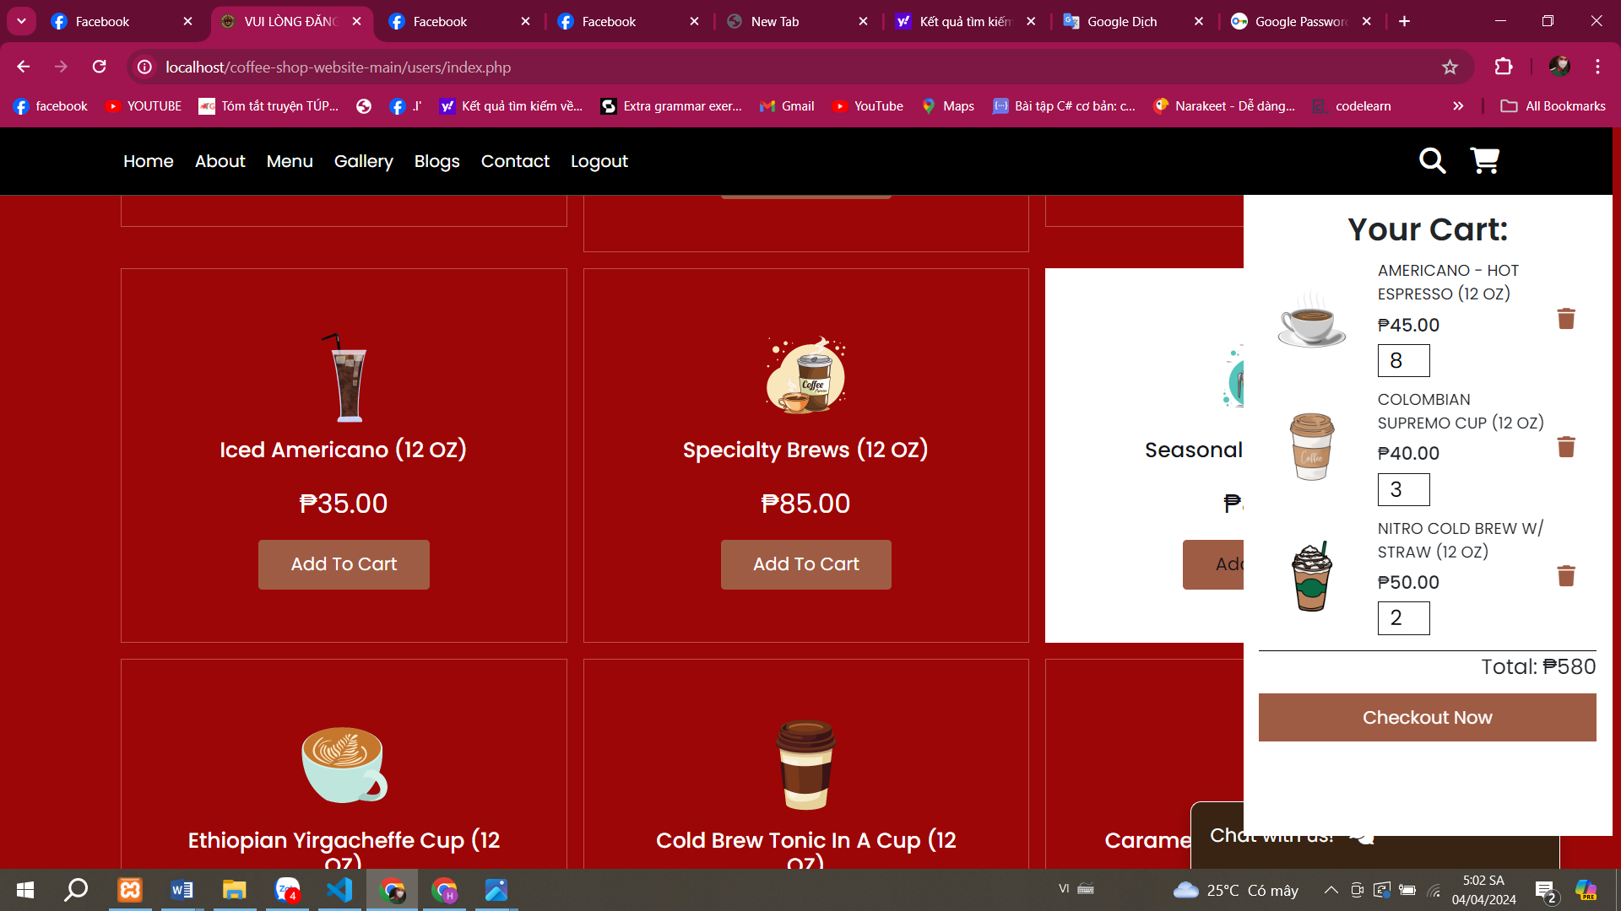

Figure 26:add to cart

1. **Account Management:**
   * Test the logout feature to ensure users are properly logged out of their accounts.

*When I click log out, I switch back to the homepage interface without logging in*

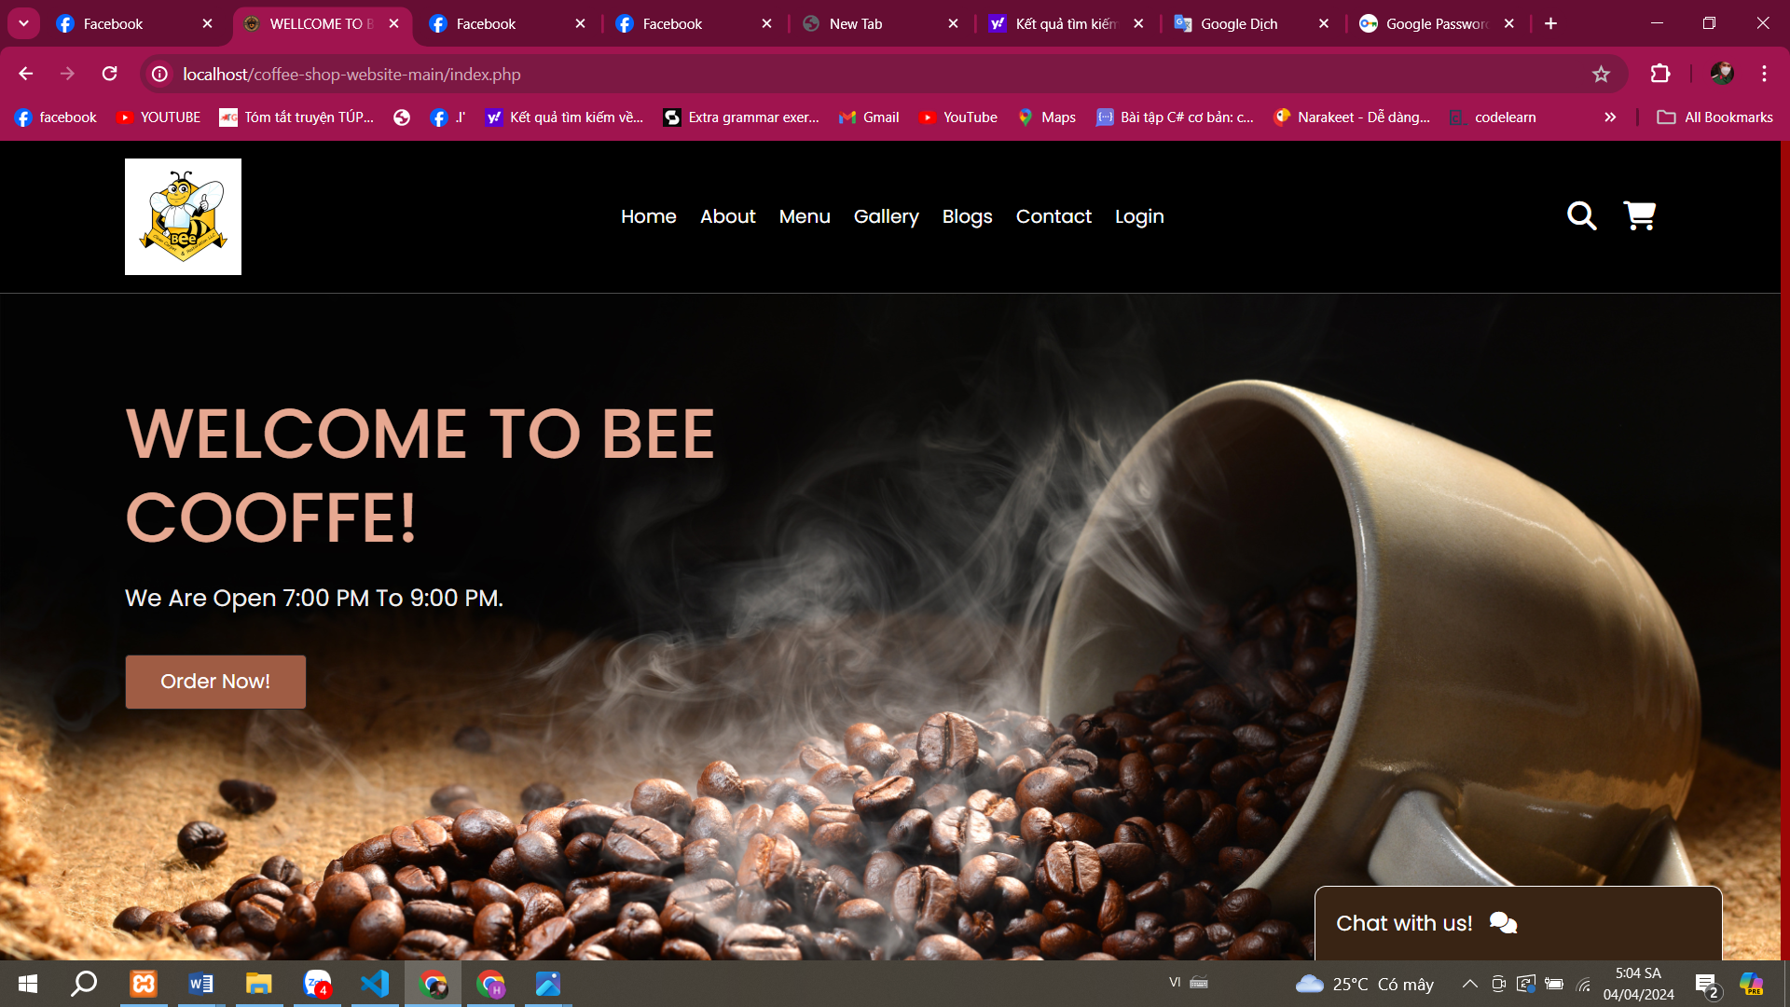

Figure 27:logout

***View Products:***

* *Test the functionality to display a list of available coffee products on the website.*

*The consistency and aesthetics of the website are very high. Can be viewed with all devices such as tablet phones, laptops, PCs... user-friendly interface*

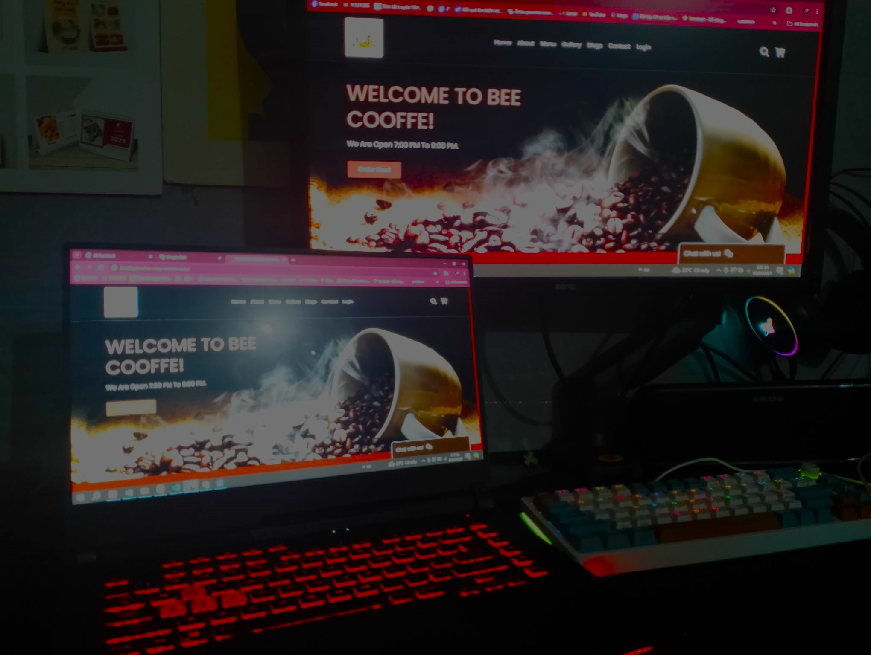

Figure 28:Multi-function device

**User Experience:**

1. **User-Friendly Interface Design:** Utilize a clean, readable, and user-friendly interface design to attract and retain users. Provide a smooth and easy shopping experience on both mobile devices and desktops.
2. **Product Search and Filtering:** Create a powerful search tool and provide options to filter products so users can easily search and choose among various types of coffee, accessories, and gifts.
3. **Product Information Sharing:** Provide detailed descriptions and high-quality images of coffee products so users can better understand the quality and origin of the products.
4. **Safe and Convenient Payment:** Integrate popular payment methods and ensure the security of users' payment information. Provide a quick and convenient payment experience.
5. **Customer Care:** Ensure that contact channels such as email, phone number, or online support are available to assist customers with any questions about products, orders, or other issues.

**Security:**

1. **User Data Protection:** Use SSL encryption to protect user data when transmitted over the network. Ensure that users' personal and payment information is securely protected.
2. **Secure Account Management:** Require users to create strong passwords and provide additional security measures such as two-factor authentication to protect their accounts.
3. **Customer Data Protection:** Comply with data security regulations such as GDPR (General Data Protection Regulation) and ensure that customer data is stored and processed securely.
4. **Regular Security Checks:** Conduct regular security checks and update the system to protect against new and emerging security threats.
5. **Cookie Management:** Provide a clear notice about the use of cookies and allow users to control cookies through browser settings.

**Test Case Sample:**

| **No.** | **Test Case** | **Input Data** | **Expected Output** | **Actual Output** | **Evaluation** |
| --- | --- | --- | --- | --- | --- |
| 1 | Test link home | N/A | Navigate to the home page | Home page is displayed with correct layout, colors, fonts, and images | Passed |
| 2 | Test link image | N/A | Click on an image link | Image link navigates to the corresponding page | Passed |
| 3 | Add product | Product details (name, price, description, image) | Product is added to the website | Product is successfully added with accurate details displayed | Passed |

Table 1:Test case

**Test UI (User Interface):**

1. **Color Test:**
   * Verify that the color scheme of the website is visually appealing and consistent across all pages.
   * Ensure that the color contrast is sufficient for readability.
   * Check for any discrepancies in color usage, such as text color, background color, and button color.
2. **Layout Test:**
   * Confirm that the layout of each page is consistent and follows a logical flow.
   * Check the alignment of elements (e.g., text, images, buttons) on different screen sizes and resolutions.
   * Ensure that all elements are properly spaced and organized for easy navigation.
3. **Font Test:**

Using **font family** in an e-commerce website offers several advantages:

Creating a First Impression: Font family plays a crucial role in creating the initial impression with customers. An appropriate font can convey professionalism, modernity, or friendliness depending on the website's style.

Increasing Brand Recognition: Utilizing distinctive font families can enhance brand recognition. When users see the unique font of the website, they can quickly identify and remember your brand.

Enhancing Consistency: Using the same font family throughout the website helps create a consistent experience. This makes the website look more professional and makes it easier for users to navigate and find information.

*Evaluation:PASSED*

1. **Image Test:**
   * Confirm that all images are displayed correctly and are of high quality.
   * Check for any broken or missing images on the website.
   * Ensure that images are appropriately sized and optimized for fast loading times.

**Test UX (User Experience):**

1. **Navigation Test:**
   * Verify that all navigation links and buttons lead to the intended pages.
   * Test the website's navigation flow to ensure a seamless user experience.
   * Check for any dead links or navigation errors.

*Evaluation: NOT PASSDED*

1. **Form and Input Test:**
   * Test all input fields (e.g., login forms, search bars, contact forms) for usability and functionality.
   * Verify that error messages are displayed correctly when users input invalid data.
   * Ensure that form validation is implemented to prevent submission of incomplete or incorrect data.

Evaluation: PASSED

1. **Responsive Design Test:**
   * Test the website's responsiveness on various devices and screen sizes.
   * Confirm that the website layout adjusts smoothly to different screen resolutions, orientations, and aspect ratios.
   * Check for any issues with touch interactions on mobile devices.

*Evaluation: Passed*

1. **Loading Speed Test:**
   * Measure the loading speed of the website on different internet connections and devices.
   * Ensure that the website loads quickly to provide a smooth user experience.
   * Optimize images, scripts, and other resources to improve loading times.

*Evaluation: NOT PASSED*

# Conclution

The design of a coffee-selling website plays a crucial role in shaping the overall user experience and brand image. Through meticulous attention to detail and adherence to design principles, we have created a visually appealing and user-friendly platform that reflects our passion for coffee.

By incorporating elements such as a suitable color palette, intuitive navigation, high-quality imagery, and responsive layout, we aimed to provide a deep and enjoyable web browsing experience for customers. The strategic use of fonts not only enhances readability but also contributes to brand recognition and emotional connection.

Moreover, our focus on usability and accessibility ensures that customers can easily explore our products, make purchases, and interact with our brand seamlessly across different devices and screen sizes. This commitment to user-centric design reflects our dedication to providing excellent service and building long-term relationships with customers.

As we continue to refine and develop our website, we are committed to maintaining progress and innovation, staying updated with new design trends and technological advancements. Through continuous improvement and innovation, we aspire to enhance the online shopping experience for coffee lovers worldwide.

# REFERENCE LIST:

**‌** www.canhcam.vn. (n.d.). *Homepage là gì? Chức năng và những lưu ý khi thiết kế trang chủ*. [online] Available at: [https://www.canhcam.vn/homepage-la-gi](https://www.canhcam.vn/homepage-la-gi%20) [Accessed 3 Apr. 2024].

itviec.com. (n.d.). *UI vs UX: Sự khác biệt giữa thiết kế UI và thiết kế UX là gì? - ITviec Blog*. [online] Available at: [https://itviec.com/blog/ui-vs-ux/](https://itviec.com/blog/ui-vs-ux/%20) [Accessed 3 Apr. 2024]

Thiết Kế Web Số. (n.d.). *Những yêu cầu khi thiết kế website*. [online] Available at: [https://thietkewebso.com/blog-cong-nghe/bai-viet/nhung-yeu-cau-khi-thiet-ke-website-887/](https://thietkewebso.com/blog-cong-nghe/bai-viet/nhung-yeu-cau-khi-thiet-ke-website-887/%20) [Accessed 3 Apr. 2024].